EMPLOYEE RIGHTS

UNDER THE FAIR LABOR STANDARDS ACT

The law requires employers to display this poster where employees can readily see it.

OVERTIME PAY | At least 1½ times the regular rate of pay for all hours worked over 40 in a workweek.
CHILD LABOR | An employee must be at least 16 years old to work in most non-farm jobs and at least 18 to work in non-farm jobs declared hazardous by the Secretary of Labor. Youths 14 and 15 years old may work outside school hours in various non-manufacturing, non-mining, non-hazardous jobs with certain work hours restrictions. Different rules apply in agricultural employment.
TIP CREDIT | Employers of “tipped employees” who meet certain conditions may claim a partial wage credit based on tips received by their employees. Employers must pay tipped employees a cash wage of at least $2.13 per hour if they claim a tip credit against their minimum wage obligation. If an employee’s tips combined with the employer’s cash wage of at least $2.13 per hour do not equal the minimum hourly wage, the employer must make up the difference.
NURSING MOTHERS | The FLSA requires employers to provide reasonable break time for a nursing mother employee who is subject to the FLSA’s overtime requirements in order for the employee to express breast milk for her nursing child for one year after the child’s birth each time such employee has a need to express breast milk. Employers are also required to provide a place, other than a bathroom, that is shielded from view and free from intrusion from coworkers and the public, which may be used by the employee to express breast milk.
ENFORCEMENT | The Department has authority to recover back wages and an equal amount in liquidated damages in instances of minimum wage, overtime, and other violations. The Department may litigate and/or recommend criminal prosecution. Employers may be assessed civil money penalties for each willful or repeated violation of the minimum wage or overtime pay provisions of the law.  Civil money penalties may also be assessed for violations of the FLSA’s child labor provisions. Heightened civil money penalties may be assessed for each child labor violation that results in the death or serious injury of any minor employee, and such assessments may be doubled when the violations are determined to be willful or repeated. The law also prohibits retaliating against or discharging workers who file a complaint or participate in any proceeding under the FLSA.
ADDITIONAL INFORMATION | - Certain occupations and establishments are exempt from the minimum wage, and/or overtime pay provisions.  - Special provisions apply to workers in American Samoa, the Commonwealth of the Northern Mariana Islands, and the Commonwealth of Puerto Rico.  - Some state laws provide greater employee protections; employers must comply with both.  - Some employers incorrectly classify workers as “independent contractors” when they are actually employees under the FLSA. It is important to know the difference between the two because employees (unless exempt) are entitled to the FLSA’s minimum wage and overtime pay protections and correctly classified independent contractors are not.  - Certain full-time students, student learners, apprentices, and workers with disabilities may be paid less than the minimum wage under special certificates issued by the Department of Labor.

WAGE AND HOUR DIVISION
UNITED STATES DEPARTMENT OF LABOR
1-866-487-9243
TTY: 1-877-889-5627
www.dol.gov/whd

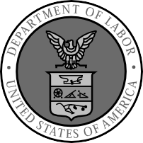


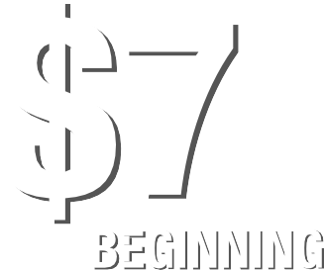







WH1088 REV 07/16

